VAGO is a best travel tool. Give you more than 50% luggage space!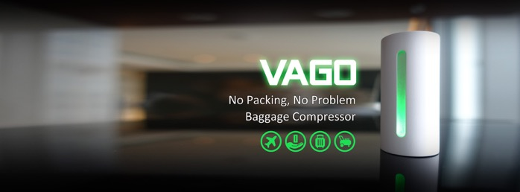
Traveling is more and more popular today and people do enjoy different cultures and embrace pleasant surprises during the journeys. From shopping-frenzy city to scenic sightseeing, what every traveler will do in common is to bring back as many souvenirs as they can. Owing to the size limit of the baggage, how to bring more back?

VAGO will be your best travel tool! Except its small & light feature, it will also automatically shrink soft things and saving space more than 50% in a short time! Use it, and you will love it!

【Saving more than 50% space】
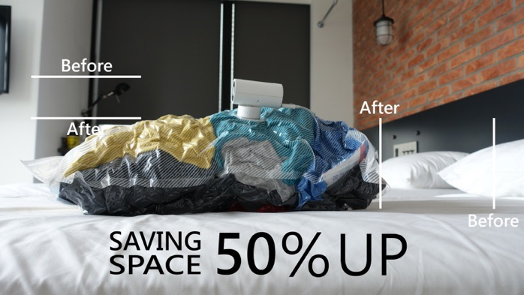
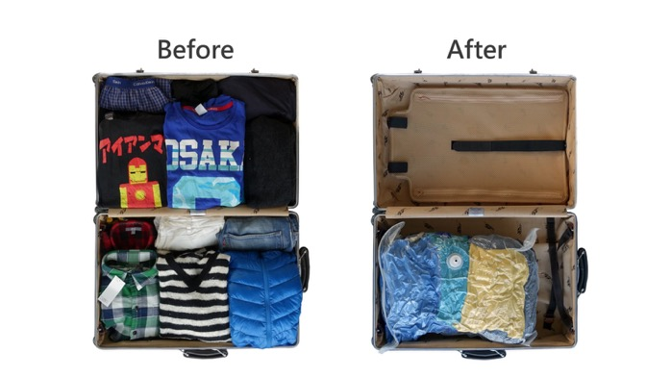
【Simple to use】
Only four-step steps to solve your big problem
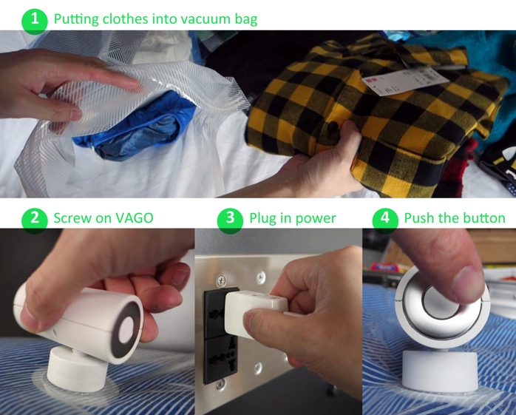
【Intelligent】
VAGO has a smart sensor to detect pressure and is able to automatically stop after full compression, saving your time and energy.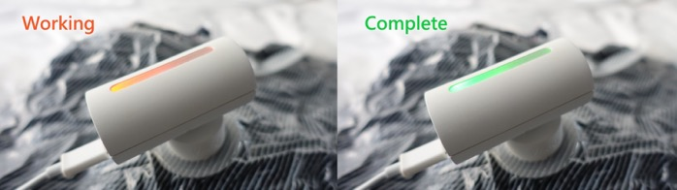
【Shopping on the way】
VAGO can also be recharged by portable batteries. It can also vacuum your bag on the go. We believe it's convenient for a shopaholic to buy more without wasting time.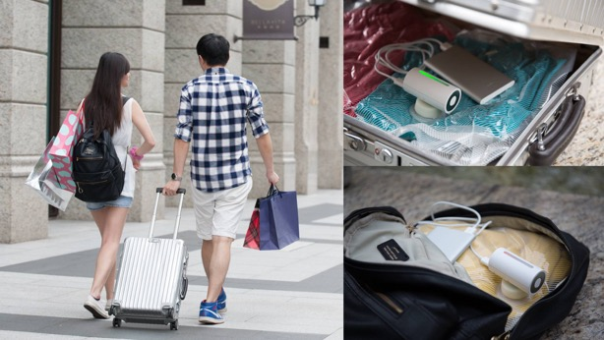
【Small & Light】
VAGO is very tiny and easily portable, with only 70 mm in length and 85 grams in weight. It is easy to carry on during your trip. (Just like the size of an egg)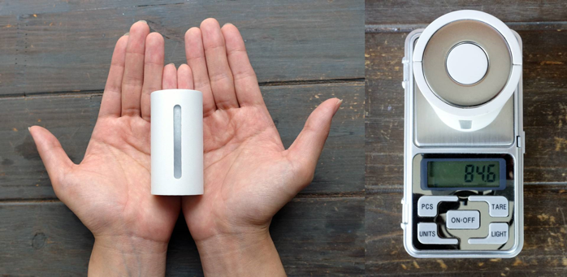
【Preventing odor & Bacteria】
Travel is fun, but you will surely carry the smelly clothes you wore during the trip. VAGO can solve this annoying problem, keeping them in a vacuum and away from odor and bacteria.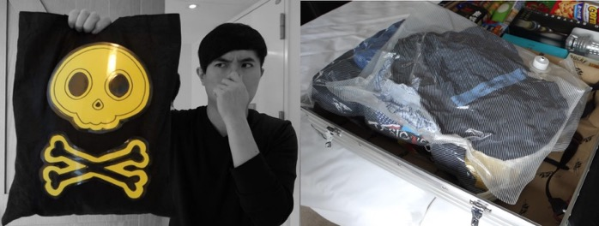
Currently, VAGO has 4 colors and will have more color collections in the nearly future. Each VAGO contains one vacuum bag (for clothes) and soft-stuff.
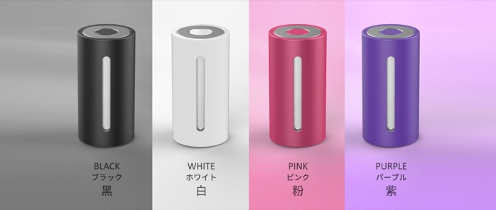
VAGO is designed by Creation Cell Company form Taiwan, and hit the target within 24 hours on kickstarter! We sincerely hope you can be the major platform to introduce VAGO. Thanks for your attention and we all look forward to get in touch with you!
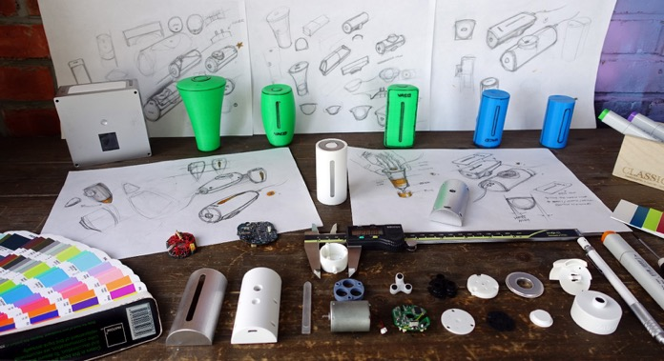

Details:

Kickstarter
https://www.kickstarter.com/projects/1632940434/vagobest-travel-toolgive-you-more-than-50-luggage

Facebook
https://www.facebook.com/CreationCell.VAGO/

Creation Cell CO.LTD
10F, No. 42-1, Xuchang St., Zhongzheng Dist.,
Taipei, Taiwan
Contact Window：Leon Chao
Phone：+886+986996231
TEL：+886+22219-7691
FAX：+886+28218-7803
E-Mail : creationcell.world@gmail.com

